Persistence for Guarantied Message Delivery

Overview

Current processing
Currently all messages are being handled by PAR Adapter (via Par Server) using synchronous CORBA call.

New requirement
- All outbound messages from OHS to PAR will be publish to event channel (OrderRouting Channel) and PAR client/workstation pick up these messages from channel.
- All inbound message from PAR to OHS will synchronous CORBA call.

The outbound messages from OHS (CBOEdirect Server) to PAR will be through asynchronous communication, OHS will publish the message to event channel/queue and PAR will pick it up. This brings an apparent possibility of PAR not been available to pickup the message from the channel at the time of publish therefore this message will get lost.
To avoid the chance of message getting lost or not delivered to PAR there will be mechanism to persist the messages (in database table) on OHS side before publish and mark this message as not processed and PAR will acknowledge this message to mark the processed flag once it receives it. In the event of PAR gets disconnected while messages were getting published and therefore didn’t received messages, it will query the OHS after it reconnects for all of its un-processed/un-ack’ed messages (processed flag marked as ‘N’) and reconcile with its local database. There is currently similar mechanism used between OHS and OMT.

The existing Routed Message table (SBTROUTEDMESSAGE) will used to achieve this goal, the sample of this table is given below:
Routed Message Table
Column Name | Data Type | Example Data
DATABASEIDENTIFIER | Num(20) | 3.35E+14
MESSAGETYPE | Num(2) | 10
CREAT_REC_TIME | Timestamp | 2011-1-12.11.32. 27. 770571000
LOCATION | Varchar2 | 9HD5
LOCATIONTYPE | Num(3) | 7
ROUTEREASON | Num(3) | 30
ROUTEDESCRIPTION | Varchar2 | Fill Report Drop Copy
ROUTECOUNT | Num(5) | 1
PROCESSEDFLAG | Char | N
ADDITIONALDATA | BLOB | (BINARY - 0 bytes)
LASTROUTETIME | Num(24) | 1.29E+12
ORDERDBID | Num(20) | 3.35E+14

Assumption
- Simple and Complex Orders/requests will use the same mechanism.
For detail please refer to Requirement document.

Implementation
The existing classes will be used for this functionality are:
- RoutedMessageHomeImpl – Home will Find or Create the Routes Message for persistence.
- RoutedMessageImpl – The message (domain object) that will be persisted for each out going message (Order, Cancel, Cancel-Replace) with processed flag and other attributes e.g. Message Type, Location, Location Type, Order DB Id etc.
- OrderHandlingService - This will be use to mark processed flag in Routes Message by PAR for each message it receives successfully.
There will be new class implemented as part for Send/Publish message to PAR functionaltity:
- WFStepAbstractToPAR – This will be used for sending Order, Cancel, Cancel-Replace to PAR using publish.

No. | Interface | Method | Direction* | Message Type | Processed Flag | Routed Message table rows effected | Comment
1 | WFStepAbstractToPAR | acceptOrders | Outbound | Send Order(s) | N | Insert 1 row
1.1 | OrderHandlingService | markMessageAsRead | Inbound | Acknowledgement | Y | Update the Order row | This is an acknowledgement for acceptOrders
2 | WFStepAbstractToPAR | acceptCancels | Outbound | Send Cancel(s) | N | Insert 1 row
2.1 | OrderHandlingService | markMessageAsRead | Inbound | Acknowledgement | Y | Update Cancel row | This is an acknowledgement for acceptCancels
3 | WFStepAbstractToPAR | acceptCancelReplaces | Outbound | Send CancelReplace(s) | N | Insert 1 row
3.1 | OrderHandlingService | markMessageAsRead | Inbound | Acknowledgement | Y | Update Cancel-Replace row | This is an acknowledgement for acceptCancelReplaces
* = Direction is based on OHS e.g. Inbound means PAR to OHS, Outbound means OHS to PAR.

Scripts
- None

Database
- Existing “SBTROUTEDMESSAGE” table will be used.

SetContext

XML/DTD

Homes/Services
- OrderHandlingService
- RoutedMessageImpl
- RoutedMessageHomeImpl

ImplPlan
- Flow Diagram
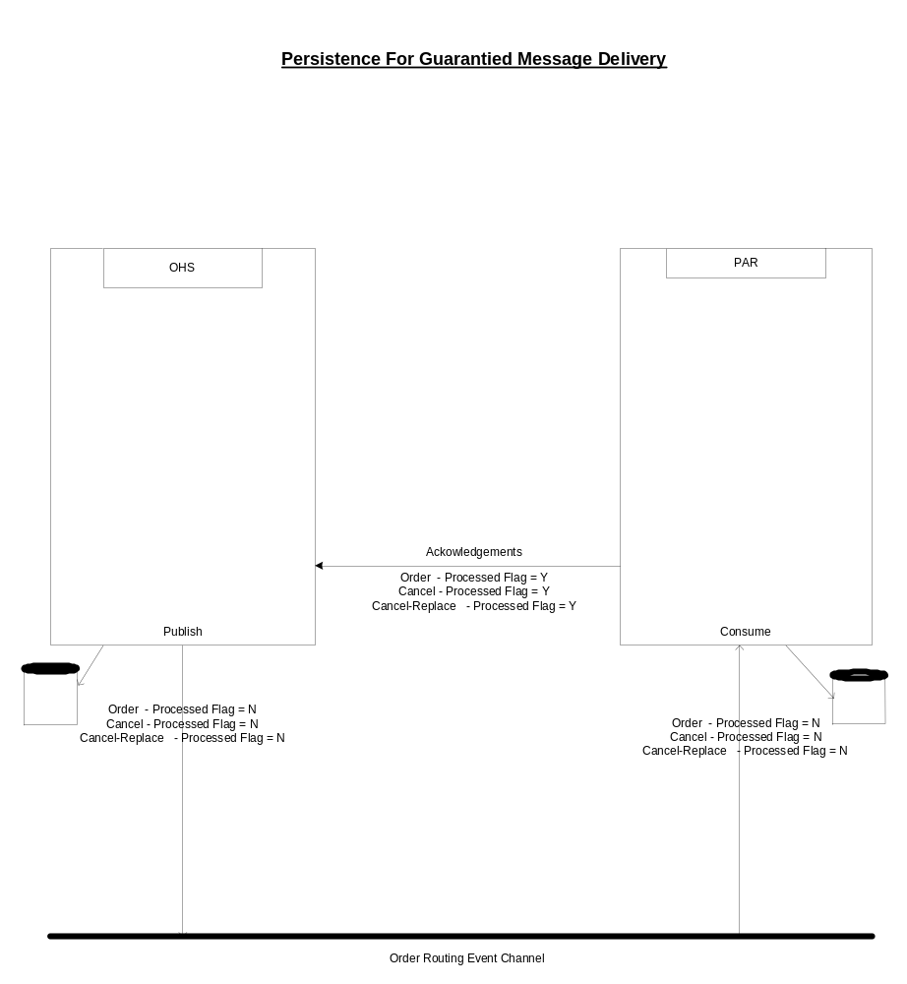
- Sequence Diagram
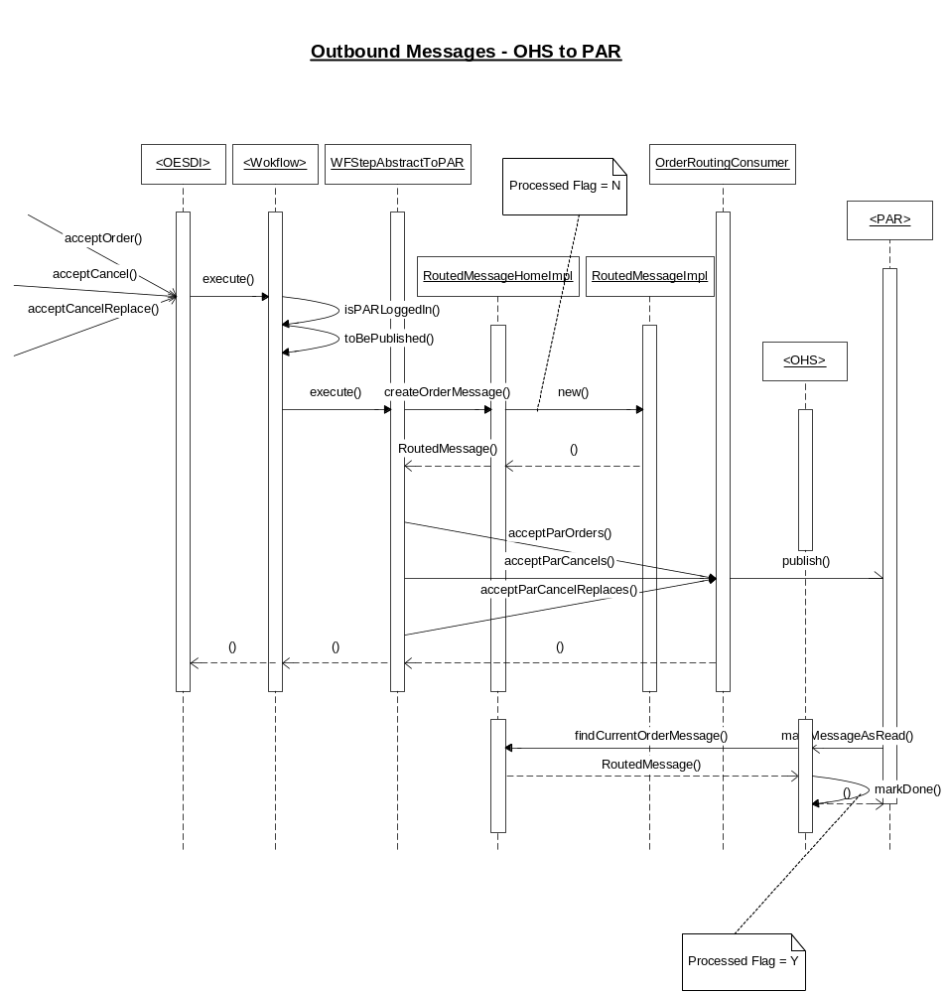

- Class Diagram
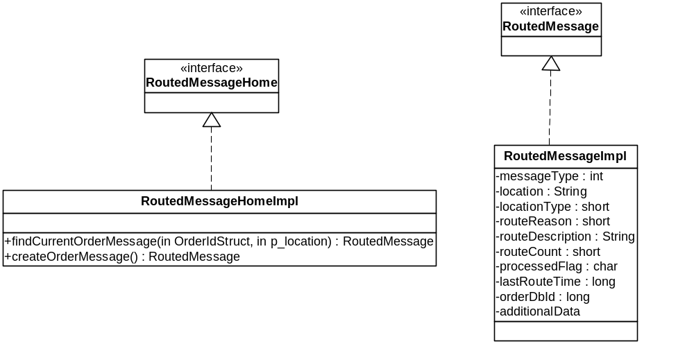

PerformanceTestingProcedure
- .

TestingProcedure

OperatorProcedure
- .

Fallback/Failover

